Join a GOOGLE class with a class code
- Go to classroom.google.com.
- At the top, click Add Join class. 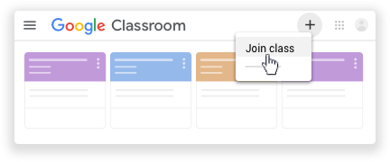
- Enter the class code your teacher gave you and click Join.
- A class code consists of 6 or 7 letters or numbers. For example, hjhmgrk or g5gdp1. 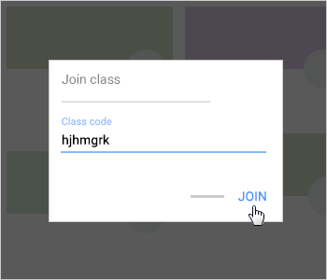
Accept an invitation from your teacher
- Go to classroom.google.com.
- On the class card, click Join. 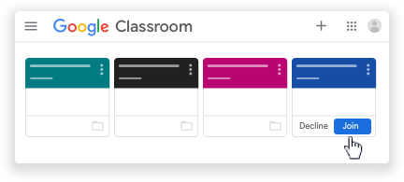

Note: Only your teacher can change the class image. However, you can change your Classroom profile photo. For instructions, see Change your profile photo.

